Road Closures along Chestnut Avenue, between Nebraska and Kamm avenues; and Mountain View Avenue, between Cedar and Peach avenues, in Fresno County.  Work includes the construction of a high-speed rail overcrossing.  Work will continue through February 2023. | NORTHBOUND TRAFFIC (CHESTNUT AVENUE)  - Traffic going northbound on Chestnut Ave will be detoured west on Conejo Avenue, north on Cedar Avenue, east on Nebraska Avenue, then north on Chestnut Avenue.  SOUTHBOUND TRAFFIC (CHESTNUT AVENUE)  - Traffic going southbound on Chestnut Avenue will be detoured west on Nebraska Avenue, south on Cedar Avenue, east on Conejo Avenue, then south on Chestnut Avenue.  EASTBOUND TRAFFIC (MOUNTAIN VIEW AVENUE)  - Traffic going eastbound on Mountain View Avenue will be detoured north on Cedar Avenue, east on Nebraska Avenue, south on Peach Avenue, then east on Mountain View Avenue.  WESTBOUND TRAFFIC (MOUNTAIN VIEW AVENUE)  - Traffic going westbound on Mountain View Avenue will be detoured north on Peach Avenue, west on Nebraska Avenue, south on Cedar Avenue, then west on Mountain View Avenue.  Signage will be in place to direct traffic.

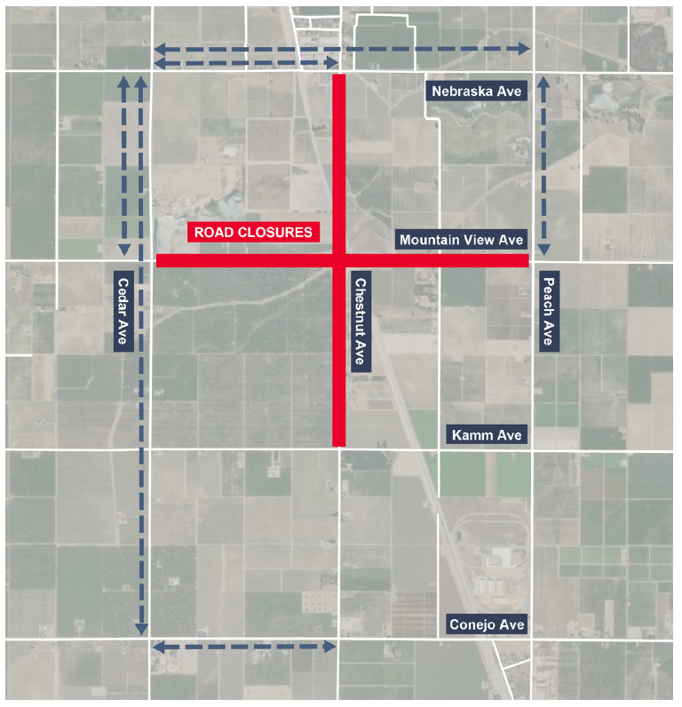

All construction activities and schedules are subject to change. The California High-Speed Rail project is considered a critical infrastructure sector, and as the project continues, staff, contractors and construction workers are following specific guidelines to ensure the health and safety of all employees due to the COVID-19 pandemic.
For up-to-date information please visit BuildHSR.com or the Caltrans Quickmap. Traffic laws will be fully enforced and commuters are expected to be aware of the surrounding activities, remain alert and watch for construction vehicles and personnel. The public is asked to drive carefully and be extra cautious while traveling through construction areas.
Para información o preguntas, por favor llame al teléfono (559) 445-6770 directo o visite el sitio web www.hsr.ca.gov
如有疑問或需要索取工程最新資料，請致電輔助熱線或參閱工程網頁
Để biết thêm thông tin hoặc là có câu hỏi, xin quý vị vui lòng gọi số điện thoạihoặc là viếng thăm trang web liệt kê phía dưới trang này:

Thank you for your patience and cooperation.
Contact: | Toni Tinoco  California High-Speed Rail  (559) 274-8975  Toni.Tinoco@hsr.ca.gov | Billy Chansombath  Dragados-Flatiron Joint Venture  (844) 746-3358​  PIM@DFCP23.com

